
Setting up Visual Studio Code IDE
- Install Python (Latest version or the most stable version) from https://www.python.org/downloads/

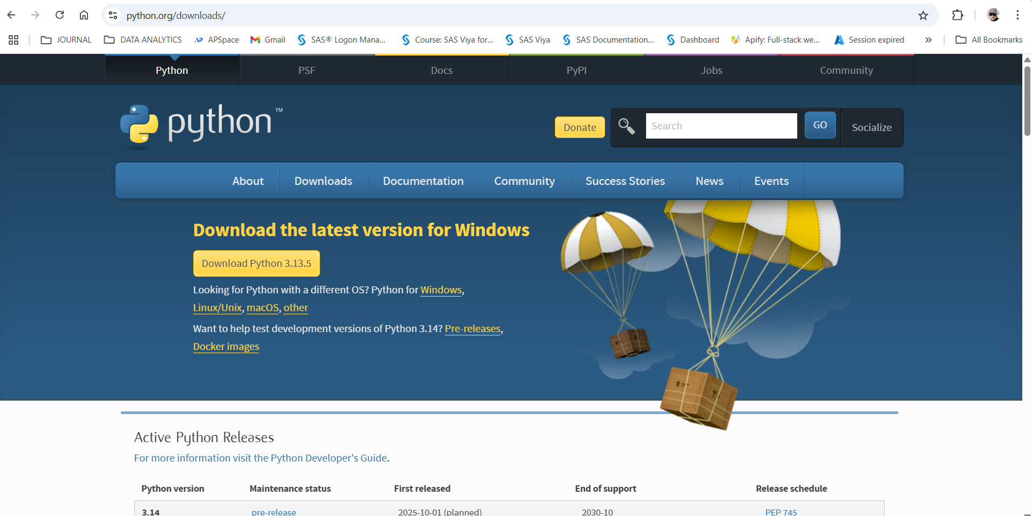

- Install Visual Studio Code IDE from https://code.visualstudio.com/download

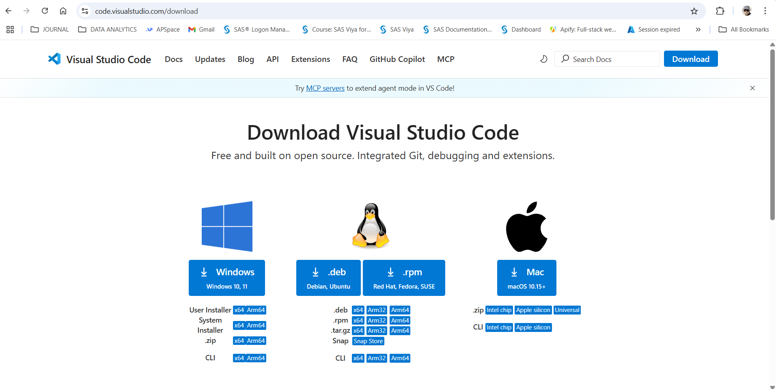

- Launch Visual Studio Code IDE and land on the Welcome page.

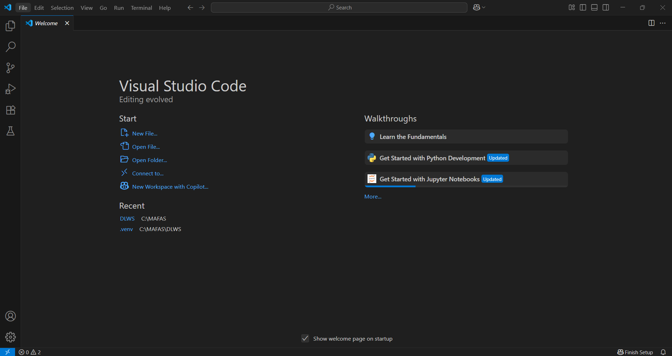

- Create a new file using Jupyter notebook.

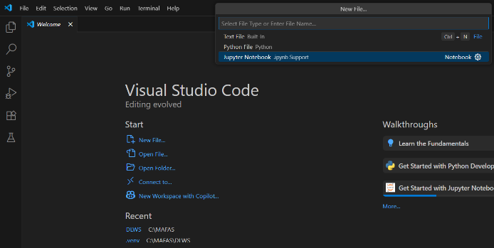
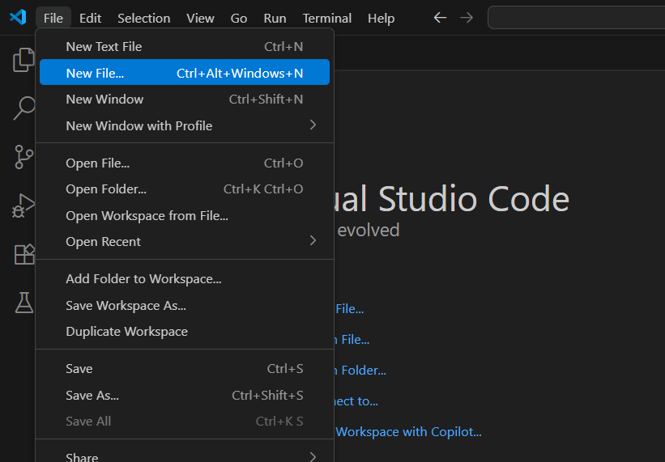

- Select the Python Kernel, if it doesn’t get selected automatically.

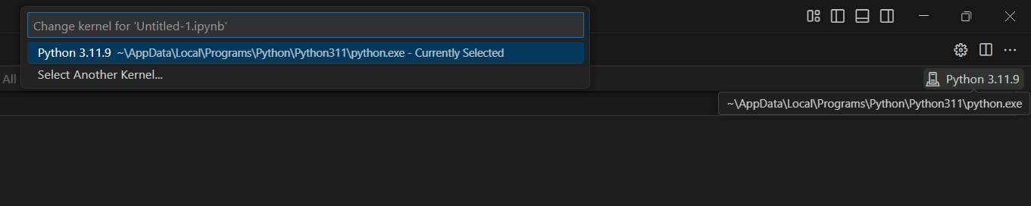

- Go to the Extensions and type “Jupyter” in the search bar and install all the Jupyter related components.

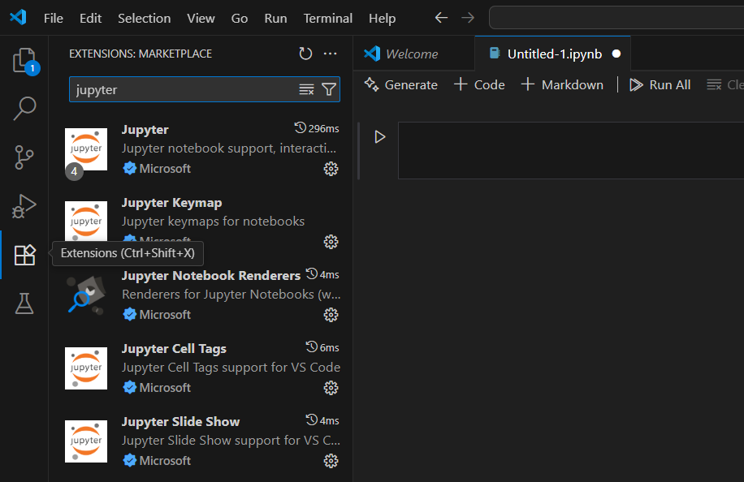

- Once it is done, your VSCode IDE is ready to use.
- Install the following libraries one by one.
1. Pandas (%pip install pandas)
2. Matplotlib (%pip install matplotlib)
3. Seaborn (%pip install seaborn)
4. Scikit-Learn (%pip install scikit-learn)
- Example:
